

**Product Dissection for Snapchat**

**Company Overview:**

Snapchat, founded in 2011 by **Evan Spiegel, Bobby Murphy, and Reggie Brown**, has emerged as a pioneering multimedia messaging app. Known for its ephemeral nature, Snapchat allows users to share photos and videos that disappear after being viewed. The platform has introduced innovative features like Stories, Filters, and Discover, reshaping how users communicate and consume content in the digital age. With a focus on self-expression and real-time communication, Snapchat has carved its niche in the dynamic landscape of social media.

**Product Dissection and Real-World Problems Solved by Snapchat:**

Snapchat has effectively addressed real-world challenges through its unique product offerings, emphasizing visual communication and dynamic content creation. Snapchat's core features provide solutions to the need for authentic self-expression, privacy, and real-time interaction.

Snapchat's **Stories** feature, where users can share a collection of photos and videos that disappear after 24 hours, solves the problem of content permanence. This ephemeral nature encourages users to share in-the-moment experiences without the fear of creating a long-lasting digital footprint. It addresses the evolving privacy concerns in the digital era by providing users with control over the visibility and duration of their shared content.

Snapchat's **Filters and Lenses** have revolutionized the way users interact with their photos and videos. By overlaying augmented reality elements, these features provide a fun and creative outlet for self-expression. This addresses the need for personalized and engaging content, allowing users to enhance their visual communication in a lighthearted manner.

The **Discover** feature on Snapchat tackles the challenge of content discovery. By curating content from various publishers and creators, Discover offers users a personalized feed of news, entertainment, and stories tailored to their interests. This innovation helps users navigate through the abundance of content available online, making content discovery more engaging and relevant.

In conclusion, Snapchat's product design has successfully tackled real-world problems by offering a platform that prioritizes privacy, encourages creativity, and provides dynamic ways to communicate. Through its unique features, Snapchat has become a trailblazer in the realm of multimedia messaging, providing practical solutions to the evolving needs of its user base.

**Case Study: Real-World Problems and Snapchat's Innovative Solutions**

**Problem 1: Permanence of Online Content**

**Real-World Challenge:** Users face concerns about the lasting impact of their shared content online, leading to self-censorship and a reluctance to share authentic experiences.

**Snapchat's Solution:** Snapchat introduced the **Stories** feature, allowing users to share photos and videos that disappear after 24 hours. This ephemeral nature encourages users to share candid, in-the-moment content without the fear of a permanent digital record. By addressing the problem of content permanence, Snapchat fosters a more authentic and spontaneous form of communication.

**Problem 2: Lack of Engaging Self-Expression**

**Real-World Challenge:** Users seek creative outlets for self-expression beyond traditional text-based communication.

**Snapchat's Solution:** **Filters and Lenses** on Snapchat provide users with a dynamic and interactive way to enhance their photos and videos. By overlaying augmented reality elements, these features add a playful and creative dimension to visual communication. This addresses the need for engaging self-expression, allowing users to convey their personalities in a fun and visually appealing manner.

**Problem 3: Overwhelming Content Landscape**

**Real-World Challenge:** The vast amount of online content can be overwhelming, making it challenging for users to discover relevant and engaging material.

**Snapchat's Solution:** The **Discover** feature on Snapchat curates content from various publishers and creators, offering users a personalized feed of news, entertainment, and stories. This personalized approach to content discovery helps users find material aligned with their interests, mitigating the challenge of navigating through an overwhelming content landscape.

**Problem 4: Stale Communication Platforms**

**Real-World Challenge:** Users seek innovative and dynamic communication platforms that go beyond traditional messaging.

**Snapchat's Solution:** Snapchat's combination of ephemeral messaging, multimedia content, and interactive features provides a fresh and dynamic communication platform. This solution addresses the need for more engaging and innovative ways to connect with others in the digital realm.

Snapchat's journey from a disappearing photo app to a multimedia messaging giant exemplifies its ability to identify real-world problems and offer innovative solutions. By prioritizing ephemeral content, augmented reality, and personalized discovery, Snapchat has become a leader in reshaping how users communicate and share in the digital age. This case study highlights how Snapchat's user-centric approach and commitment to innovation have positioned it as a revolutionary force in the realm of multimedia messaging.

**Top Features of Snapchat:**

1. **Stories:** Users can share a collection of photos and videos that disappear after 24 hours, providing an ephemeral way to capture and share moments.
2. **Filters and Lenses:** Augmented reality features that overlay creative elements on photos and videos, enhancing self-expression and visual communication.
3. **Discover:** A curated feed of content from publishers and creators, offering personalized news, entertainment, and stories based on user interests.
4. **Snap Map:** A feature that allows users to share their location on a map with friends, fostering real-time connection and interaction.
5. **Stickers and Emojis:** Fun and expressive visual elements that users can add to their snaps, adding a playful touch to communication.
6. **Chat:** A messaging feature that supports real-time communication, including text, voice, and video chat options.
7. **Memories:** A feature that allows users to save and revisit their favorite snaps and stories, creating a personal archive of memories.

**Schema Description:**

The schema for Snapchat involves multiple entities that capture different aspects of the platform. These entities include Users, Snaps, Stories, Filters, Lenses, Discover Content, and more. Each entity has specific attributes describing its properties and relationships with other entities.

**User Entity:**

* **UserID (Primary Key):** A unique identifier for each user.
* **Username:** The chosen username for the user's account.
* **Email:** The user's email address for account-related communication.
* **Registration_Date:** The date when the user joined Snapchat.

**Snap Entity:**

* **SnapID (Primary Key):** A unique identifier for each snap.
* **UserID (Foreign Key referencing User Entity):** The user who created the snap.
* **Content:** The visual content of the snap (photo or video).
* **Creation_Date:** The date and time when the snap was created.

**Story Entity:**

* **StoryID (Primary Key):** A unique identifier for each story.
* **UserID (Foreign Key referencing User Entity):** The user who created the story.
* **Expiration_Date:** The date and time when the story expires.

**Filter Entity:**

* **FilterID (Primary Key):** A unique identifier for each filter.
* **Name:** The name of the filter.
* **Overlay_Image:** The image or graphic used as the filter overlay.

**Lens Entity:**

* **LensID (Primary Key):** A unique identifier for each lens.
* **Name:** The name of the lens.
* **AR_Elements:** The augmented reality elements used in the lens.

**Discover Content Entity:**

* **ContentID (Primary Key):** A unique identifier for each piece of Discover content.
* **Title:** The title of the Discover content.
* **Publisher:** The entity or user responsible for creating the content.

**Relationships:**

* **Users create Snaps:** Each user can create multiple snaps.
* **Users contribute to Stories:** Users can contribute snaps to multiple stories, and each story can have multiple contributors.
* **Filters are used in Snaps:** Multiple snaps can use the same filter, and each snap can have only one filter.
* **Lenses are used in Snaps:** Multiple snaps can use the same lens, and each snap can have only one lens.
* **Discover Content is created by Users:** Users or entities create multiple pieces of Discover content, and each piece of content is associated with one creator.

**ER Diagram:**

Constructing an ER diagram for Snapchat involves visually representing the entities, attributes, and relationships described above. The ER diagram illustrates how users, snaps, stories, filters, lenses, and discover content interact within the Snapchat data model.

**Recommended Schema**:

**Star SchemaReasoning**: The star schema is designed for analytical queries, as it separates fact tables containing quantitative data from dimension tables providing context. This separation facilitates efficient querying and reporting.

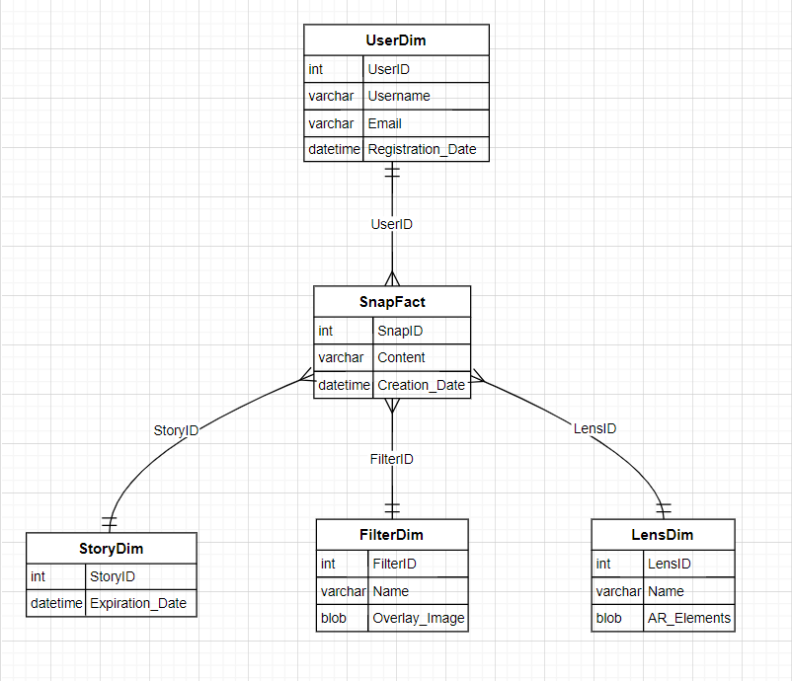

**Conclusion:**

In this case study, we explored the design of Snapchat's schema, delving into the entities, attributes, and relationships that define the platform's data model. Snapchat's innovative features, such as Stories, Filters, Lenses, and Discover, contribute to its unique identity in the realm of multimedia messaging. By understanding the schema, we gain insights into how Snapchat effectively manages user interactions, content creation, and discovery, contributing to its popularity and ongoing impact on digital communication.